Rish's Gym Program
6-Day Split with Progressive Overload Scheme

How the Progression Works
This program uses double progression: you work within a rep range for every exercise instead of chasing a fixed number. Progress the weight only once you've earned it.
- Pick a starting weight where the last 1–2 reps of your first set feel genuinely hard, but every rep is done with good form. Write this into the 'Week 1' box for each exercise the next time you're at the gym.
- Each session, try to add one rep to any set that's below the top of its rep range, keeping the same weight.
- Once you can complete the top of the rep range for ALL working sets of an exercise, increase the weight by the amount shown in that exercise's table (e.g. '+2.5 kg') and drop back to the bottom of the rep range.
- If you DON'T hit the top of the rep range yet, repeat the previous week's weight instead of adding the suggested increase — the '+X kg' notes are a ceiling on how much to add, not a requirement to add it on schedule.
- For bodyweight moves marked 'add reps first' (pull-ups, hanging knee raise, ab wheel rollout), don't add external weight until you're comfortably hitting the top of the rep range — then add a small amount via a dip belt or weighted vest.

4-Week Wave + Deload
- Weeks 1–4: follow the sets/reps/rest listed for each exercise, applying double progression above.
- Week 5 (deload): cut sets by roughly 40% on every exercise (e.g. 4 sets → 2, 3 sets → 2) and use about 60–70% of the weight you were using in Week 4. This is not optional if you want to keep progressing — it lets your joints and nervous system catch up before the next wave.
- After the deload, restart at Week 1 with the new, heavier starting weights from wherever you left off pre-deload.

General Rules
- Warm up compound lifts (Squat, RDL, Bench/Incline Press) with 2–3 ramp-up sets before your first working set — these aren't counted in the sets above.
- If a lift stalls for 3 straight sessions (no rep or weight increase), drop the weight ~10% and rebuild — this is normal, not a failure.
- Sleep and protein intake drive whether this progression scheme actually works. Without them, added weight on the bar will stall regardless of effort in the gym.

If You Miss a Gym Day
- Treat the split as rolling, not calendar-locked — if you miss Thursday's Legs day, just do it Friday, and every day after shifts back by one.
- Avoid stacking two heavy sessions for the same muscle group back-to-back — leave at least a day of gap between them where possible.
- If a missed day would otherwise force 3 straight lifting days in a row, drop that week's Friday recovery walk/mobility session instead of skipping a lifting day.
- If you miss two days in a row, don't cram both sessions back-to-back — just resume the split from wherever you are and let the missed session roll into next week.
- Don't add extra volume elsewhere to 'make up' for a skipped muscle group — one missed session per month has minimal impact on progress; doubling up elsewhere risks overtraining.

Tuesday — Chest Priority
Incline Dumbbell Press
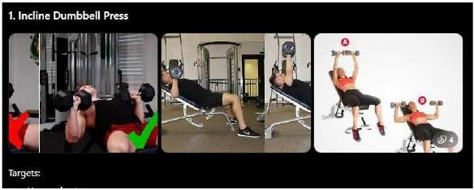
Sets | Reps | Rest | Week 1 | Week 2 | Week 3 | Week 4
4 | 6–8 | 2–3 min | ____ kg | +2.5–5 kg | +2.5–5 kg | +2.5–5 kg

Flat Dumbbell Bench Press
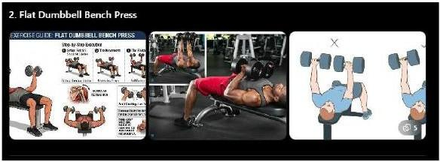
Sets | Reps | Rest | Week 1 | Week 2 | Week 3 | Week 4
3 | 8–10 | 2 min | ____ kg | +2–2.5 kg | +2–2.5 kg | +2–2.5 kg

Machine Chest Press
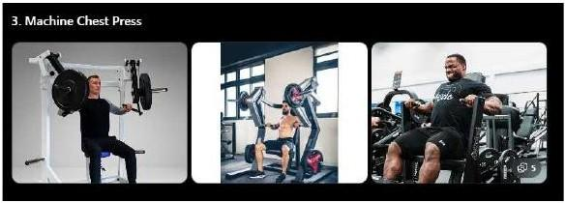
Sets | Reps | Rest | Week 1 | Week 2 | Week 3 | Week 4
3 | 8–10 | 90 sec | ____ kg | +2–2.5 kg | +2–2.5 kg | +2–2.5 kg

High-to-Low Cable Fly

Sets | Reps | Rest | Week 1 | Week 2 | Week 3 | Week 4
3 | 12–15 | 60 sec | ____ kg | +1–2 kg | +1–2 kg | +1–2 kg

Dumbbell Lateral Raise
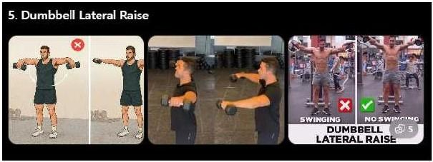
Sets | Reps | Rest | Week 1 | Week 2 | Week 3 | Week 4
3 | 12–15 | 60 sec | ____ kg | +1–2 kg | +1–2 kg | +1–2 kg

Rope Triceps Pushdown
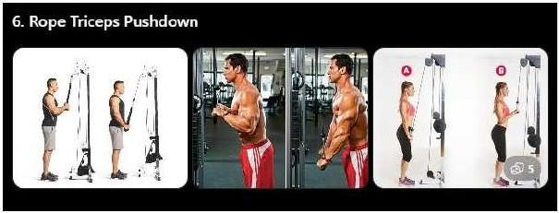
Sets | Reps | Rest | Week 1 | Week 2 | Week 3 | Week 4
3 | 10–12 | 60 sec | ____ kg | +1–2 kg | +1–2 kg | +1–2 kg

Overhead Rope Extension
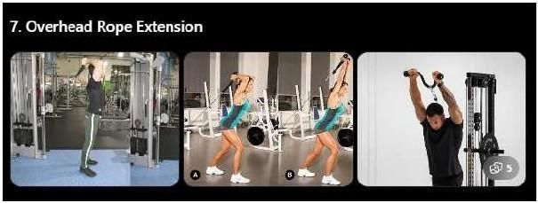
Sets | Reps | Rest | Week 1 | Week 2 | Week 3 | Week 4
3 | 10–12 | 60 sec | ____ kg | +1–2 kg | +1–2 kg | +1–2 kg

Hanging Knee Raise
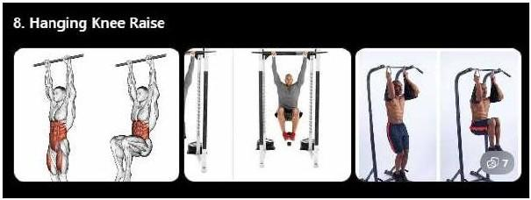
Sets | Reps | Rest | Week 1 | Week 2 | Week 3 | Week 4
3 | 12–15 | 60 sec | ____ kg | add reps first | add reps first | add reps first

Pallof Press
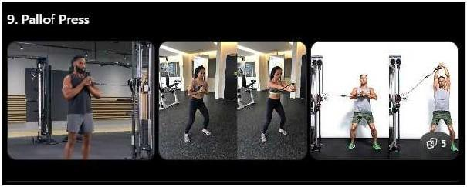
Sets | Reps | Rest | Week 1 | Week 2 | Week 3 | Week 4
3 | 12/side | 45 sec | ____ kg | +1–2 kg | +1–2 kg | +1–2 kg

Wednesday — Back & Biceps
Pull-ups
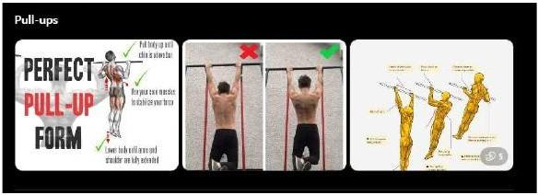
Sets | Reps | Rest | Week 1 | Week 2 | Week 3 | Week 4
4 | 6–10 | 2 min | ____ kg | add reps first | add reps first | add reps first

Wide Grip Lat Pulldown
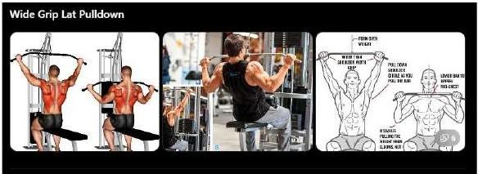
Sets | Reps | Rest | Week 1 | Week 2 | Week 3 | Week 4
3 | 8–10 | 90 sec | ____ kg | +2–2.5 kg | +2–2.5 kg | +2–2.5 kg

Chest Supported Row
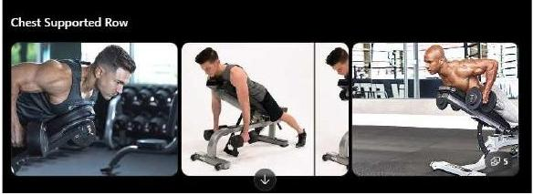
Sets | Reps | Rest | Week 1 | Week 2 | Week 3 | Week 4
3 | 8–10 | 90 sec | ____ kg | +2–2.5 kg | +2–2.5 kg | +2–2.5 kg

One Arm Cable Row
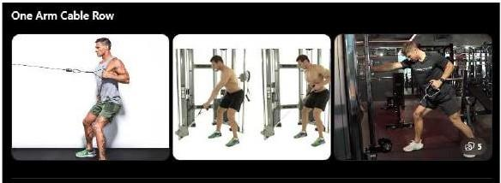
Sets | Reps | Rest | Week 1 | Week 2 | Week 3 | Week 4
3 | 10–12 | 75 sec | ____ kg | +1–2 kg | +1–2 kg | +1–2 kg

Straight Arm Pulldown
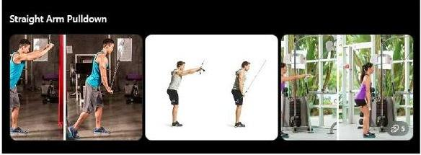
Sets | Reps | Rest | Week 1 | Week 2 | Week 3 | Week 4
3 | 12–15 | 60 sec | ____ kg | +1–2 kg | +1–2 kg | +1–2 kg

Incline Dumbbell Curl
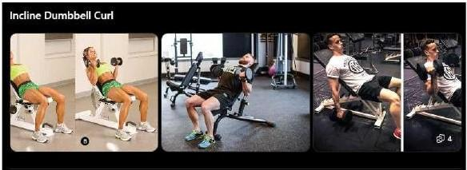
Sets | Reps | Rest | Week 1 | Week 2 | Week 3 | Week 4
3 | 10–12 | 60 sec | ____ kg | +1–2 kg | +1–2 kg | +1–2 kg

Hammer Curl
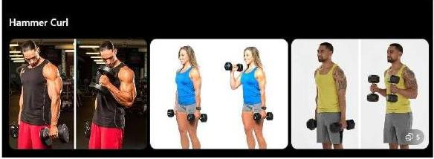
Sets | Reps | Rest | Week 1 | Week 2 | Week 3 | Week 4
3 | 10–12 | 60 sec | ____ kg | +1–2 kg | +1–2 kg | +1–2 kg

Face Pull
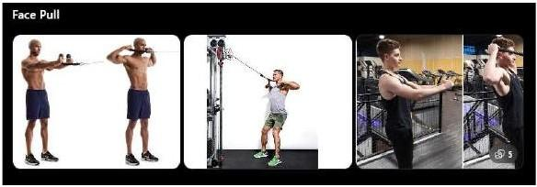
Sets | Reps | Rest | Week 1 | Week 2 | Week 3 | Week 4
3 | 15 | 45 sec | ____ kg | +1–2 kg | +1–2 kg | +1–2 kg

Thursday — Legs
Back Squat
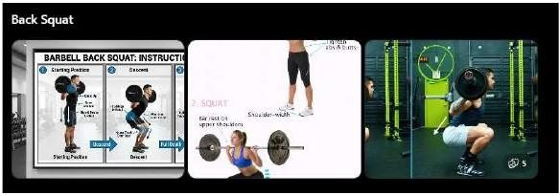
Sets | Reps | Rest | Week 1 | Week 2 | Week 3 | Week 4
4 | 6–8 | 2–3 min | ____ kg | +2.5–5 kg | +2.5–5 kg | +2.5–5 kg

Bulgarian Split Squat

Sets | Reps | Rest | Week 1 | Week 2 | Week 3 | Week 4
3 | 8–10/leg | 90 sec | ____ kg | +2–2.5 kg | +2–2.5 kg | +2–2.5 kg

Leg Press
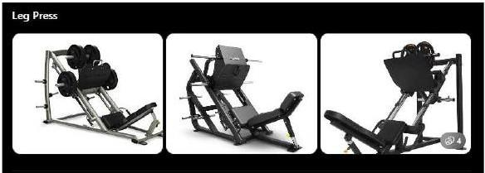
Sets | Reps | Rest | Week 1 | Week 2 | Week 3 | Week 4
3 | 10–12 | 90 sec | ____ kg | +2–2.5 kg | +2–2.5 kg | +2–2.5 kg

Leg Extension
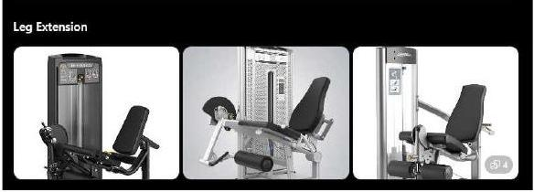
Sets | Reps | Rest | Week 1 | Week 2 | Week 3 | Week 4
3 | 12–15 | 60 sec | ____ kg | +1–2 kg | +1–2 kg | +1–2 kg

Standing Calf Raise
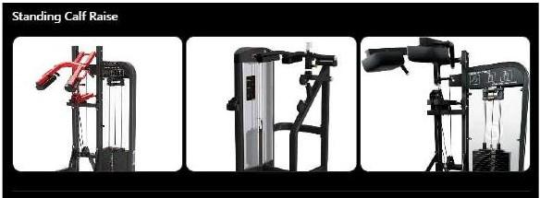
Sets | Reps | Rest | Week 1 | Week 2 | Week 3 | Week 4
4 | 12–15 | 60 sec | ____ kg | +1–2 kg | +1–2 kg | +1–2 kg

Cable Crunch
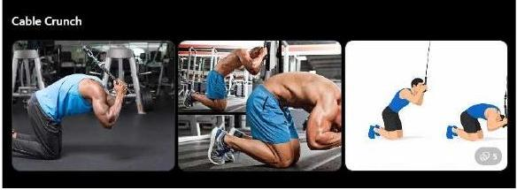
Sets | Reps | Rest | Week 1 | Week 2 | Week 3 | Week 4
3 | 12–15 | 60 sec | ____ kg | +1–2 kg | +1–2 kg | +1–2 kg

Saturday — Upper
Incline Smith Machine Press
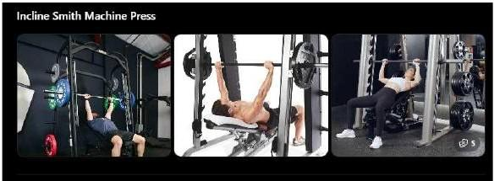
Sets | Reps | Rest | Week 1 | Week 2 | Week 3 | Week 4
4 | 6–8 | 2 min | ____ kg | +2.5–5 kg | +2.5–5 kg | +2.5–5 kg

Seated Cable Row
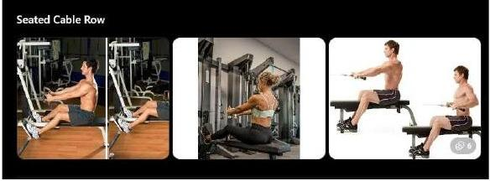
Sets | Reps | Rest | Week 1 | Week 2 | Week 3 | Week 4
4 | 8–10 | 2 min | ____ kg | +2–2.5 kg | +2–2.5 kg | +2–2.5 kg

Neutral Grip Lat Pulldown
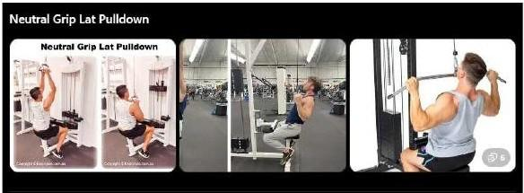
Sets | Reps | Rest | Week 1 | Week 2 | Week 3 | Week 4
3 | 10–12 | 90 sec | ____ kg | +2–2.5 kg | +2–2.5 kg | +2–2.5 kg

Machine Shoulder Press
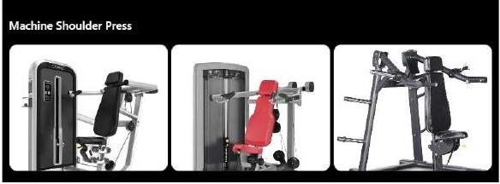
Sets | Reps | Rest | Week 1 | Week 2 | Week 3 | Week 4
3 | 8–10 | 90 sec | ____ kg | +2–2.5 kg | +2–2.5 kg | +2–2.5 kg

Reverse Pec Deck
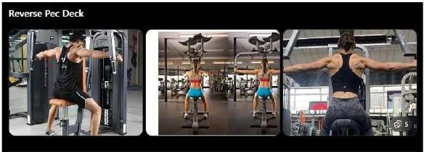
Sets | Reps | Rest | Week 1 | Week 2 | Week 3 | Week 4
3 | 12–15 | 60 sec | ____ kg | +1–2 kg | +1–2 kg | +1–2 kg

EZ Bar Curl

Sets | Reps | Rest | Week 1 | Week 2 | Week 3 | Week 4
3 | 10–12 | 60 sec | ____ kg | +1–2 kg | +1–2 kg | +1–2 kg

EZ Bar Skull Crusher

Sets | Reps | Rest | Week 1 | Week 2 | Week 3 | Week 4
3 | 10–12 | 60 sec | ____ kg | +1–2 kg | +1–2 kg | +1–2 kg

Sunday — Posterior Chain
Romanian Deadlift
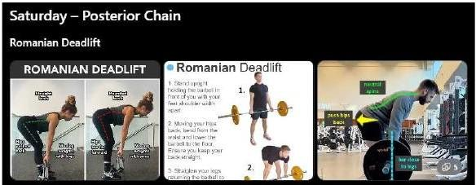
Sets | Reps | Rest | Week 1 | Week 2 | Week 3 | Week 4
4 | 6–8 | 2–3 min | ____ kg | +2.5–5 kg | +2.5–5 kg | +2.5–5 kg

Hip Thrust
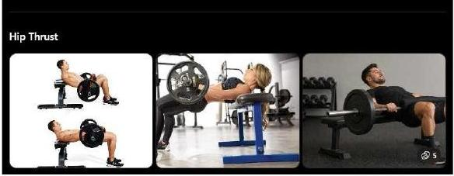
Sets | Reps | Rest | Week 1 | Week 2 | Week 3 | Week 4
3 | 8–10 | 2 min | ____ kg | +2–2.5 kg | +2–2.5 kg | +2–2.5 kg

Lying Leg Curl
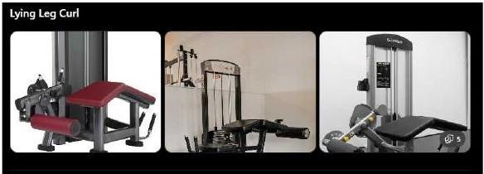
Sets | Reps | Rest | Week 1 | Week 2 | Week 3 | Week 4
3 | 10–12 | 90 sec | ____ kg | +1–2 kg | +1–2 kg | +1–2 kg

Walking Lunges
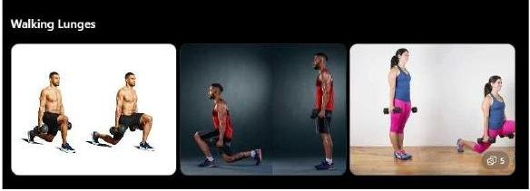
Sets | Reps | Rest | Week 1 | Week 2 | Week 3 | Week 4
3 | 10/leg | 90 sec | ____ kg | +2–2.5 kg | +2–2.5 kg | +2–2.5 kg

Seated Calf Raise
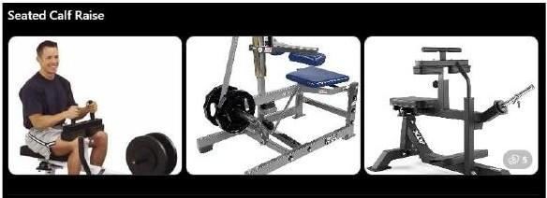
Sets | Reps | Rest | Week 1 | Week 2 | Week 3 | Week 4
4 | 12–15 | 60 sec | ____ kg | +1–2 kg | +1–2 kg | +1–2 kg

Ab Wheel Rollout
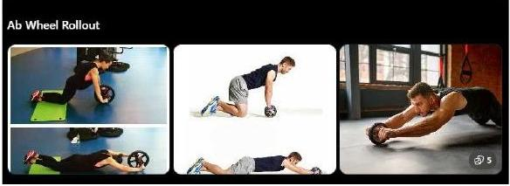
Sets | Reps | Rest | Week 1 | Week 2 | Week 3 | Week 4
3 | 10–12 | 60 sec | ____ kg | add reps first | add reps first | add reps first

